**The Oval: Cast| Office | Season 2** 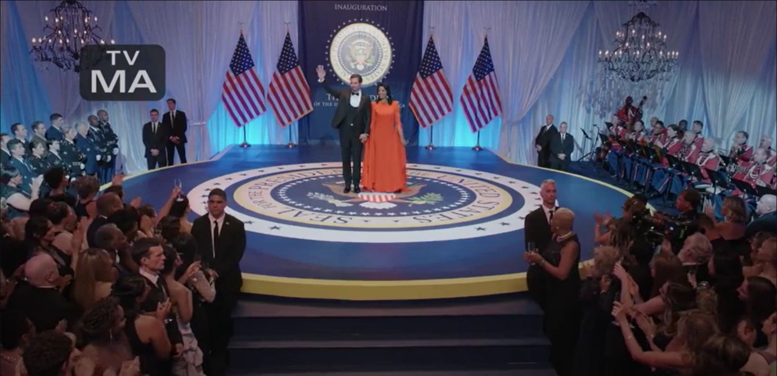

**The Oval** is an American Television series written, directed and executive-produced by **Tyler Perry**.

**The Oval** is a drama series that revolves around the day-to-day lives of the staff workers who’re liable for running the **White House**. It first season was broadcasted on October 23, 2019 on BET. And production for second season began on August 4, 2020 after the agreement upon renewal on April 27, 2020.

**The Oval: *Cast***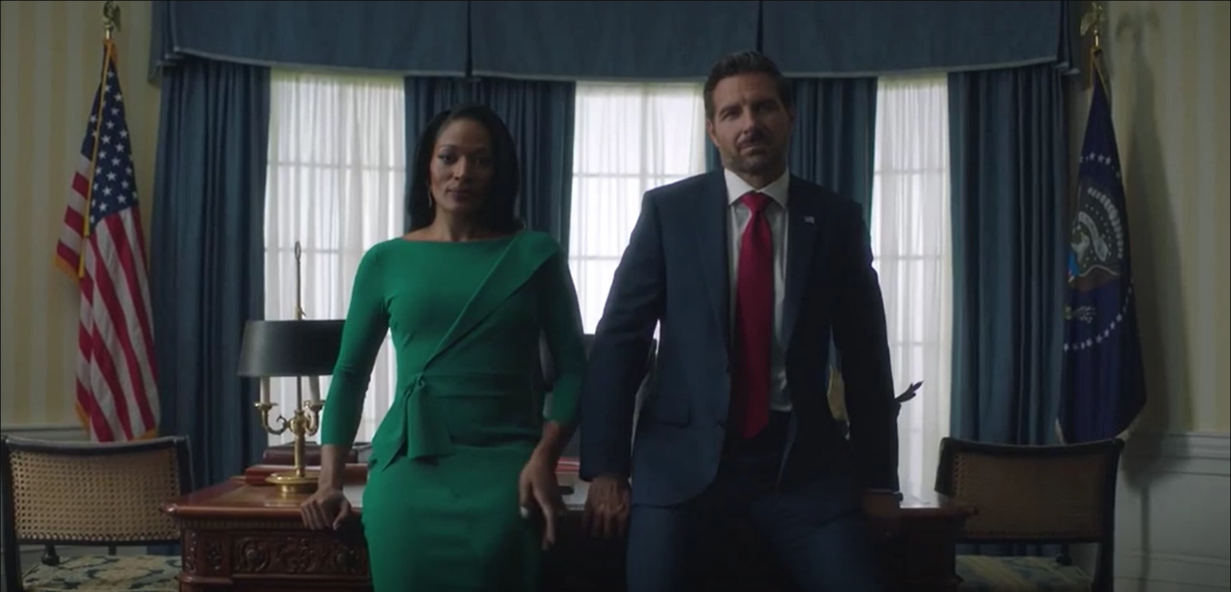

|  |  |
| --- | --- |
| Character | Actor |
| Hunter Franklin, the US Prez | Ed Quinn |
| Victoria Franklin, the First Lady | Kroon Moore |
| Gayle Franklin, Hunter and Victoria’s Daughter | Paige Hurd |
| Jason Franklin, Hunter and Victoria’s Son | Daniel Croix Henderson |
| Richard Hallsen, The Buttler | Javon johnson |
| Nancy Hallsen, The Buttler’s wife | Ptosha Storey |
| Barry Hallsen, The Butler’s son | Vaughn W. Hebron |
| Sharon | Teesha Renee |
| Donald Winthrop | Lodric Collins |
| Lilly Winthrop | Ciera Payton |
| Priscilla Owen | Taja V. simpson |
| Sam Owen | Walter Fauntleroy |
| Kyle Flint | Brad Benedict |
| Bobby | Travis Cure |
| Kareem Richardson | Matthew Law |
| Ruth Hartman/ Denise Truesdale | Melissa L. Williams |
| Max Carter | Bill Barrett |
| Lindsay Yuma | Maurii Davenport |
| Jean Peterson | Ashley Monique Harper |
| Allan | Nick Barrotta |
| Ellie Lyles | Natasha Ward |
| Diane Wilmont | Gillian White |

**The Oval: *Plot***

It depicts the story of a household who’re kept in the **White House** by the people of power. It also shades light on the personal side and day-to-day lives of the **working staff** who manages the interior functioning of the US most iconic and recognizable **residence**.

**The Oval *season 2, release date***

Because of the ongoing pandemic, the production for the ***season 2*** of **The Oval** was on halt for a while but later on it resumed. So, we’re anticipating **The Oval *season 2*** to release by 2021. But there’s no official announcement from the creator of **The oval** side.

**The Oval: *Spin-off***

**Ruthless**, an American drama series featuring Mellisa L. Williams was first premiered on March 19, 2020 as the spin-off of The Oval.

Since the trailer for **The Oval** ***season 2*** is not yet out, So, enjoy **The Oval *Season 1* Trailer** 😊

https://www.youtube.com/watch?v=Jd1Oh1e_HEE